Student Registration System

Assignment 2 Software Project Team Formation and GitHub Collaboration

Group 9

Lewis Russ
Samuel Montalvo Brousett
Tommy Martinez
Dwyhan Angulo

COP1047C Introduction to Python Programming

Professor Jhon Romero

June 12, 2026

Project Name:
Student Registration System
Team Member Names:
- Lewis Russ
- Dwyhan Angulo
- Samuel Montalvo Brousett
- Tommy Martinez

Project Description
Student registration systems are designed to help colleges maintain student records and course registration records efficiently. The team members listed in the project will develop a system that can maintain up to “25” registration records. These records will store important information such as student ID, student names, and registration status. Furthermore, the registration status will inform admins whether the student is registered, waitlisted, or dropped the course.

Standard functional requirements will allow admins to add, search, display, and update all records before allowing them to exit the program. In addition, a summary report will be generated which will provide an overview of registration activity by displaying the total number of registrations, registered students, waitlisted students, and dropped students. By doing so, this system will reduce manual errors, improve organization, and provide a more efficient manner for tracking the enrollment data of students.

Problem Statement
Many universities rely on multiple systems or manual methods to manage student records. These methods make it difficult to maintain accurate records and efficiently organize student information. As the number of student enrollment increases, so does the workload in terms of managing student records. Manual methods can lead to data errors and inefficiencies in record management.

The Student Registration System that our team will incorporate will address these challenges to provide maximum efficiency. By providing a centralized system for storing and managing records for registration. This system will allow admins to add, search, display, update, and generate a detailed summary report. This will improve accuracy and efficiency when managing student enrollment data.

Project Goals
The primary goals of the Student Registration System are:
- Maintain up to 25 student registration records.
- Store Student ID, Student Name, and Registration Status information.
- Allow administrators to add new registration records.
- Allow administrators to search for existing registration records.
- Display all registration records within the system.
- Update student registration status when necessary.
- Generate summary reports for registration activity.
- Improve the accuracy and organization of student enrollment data.

Expected Inputs
The Student Registration System will have the following inputs for administrators:
• Student ID
• Student Name
• Registration Status
• Search Criteria (Student ID or Student Name)
• Updated Registration Information
Valid Registration Status Values
• Registered
• Waitlisted
• Dropped

Expected Outputs
The Student Registration System will generate the following outputs:
• Student registration records
• Search results based on Student ID or Student Name
• Updated registration information
• A complete list of all registration records
• Registration summary reports
Summary Report Information
• Total Registrations
• Registered Students
• Waitlisted Students
• Dropped Students

Generate Summary Report:
Generate summary report will generate a report showing the total number of registrations, registered students, waitlisted students, and dropped students. This report will help admins to monitor student enrollment activity.

Exit Program
This feature will allow users to safely close the program when all tasks have been completed.
Project Design
The Student Registration System will be organized into a group of major functions, where each function handles one task in the program. Breaking the program into separate functions keeps it organized and easy to follow, and it lets the team divide the work during the programming phase. The functions listed below match the six required features of the system and the steps shown in the system flowchart. These functions will be created during the coding phase of the project.
Program Flow
When the program starts, it will display a main menu and use a while loop so the menu returns after each task is finished. The administrator types a number to choose an option, and an if, elif, and else structure sends the program to the matching function. The program keeps running until the administrator chooses the exit option.

Major Functions
The table below identifies the major functions that will eventually be developed, along with the purpose, expected inputs, and resulting output of each.

Function | Purpose | Inputs | Output / Result
add_record() | Adds a new student registration record to the system, up to the limit of 25 records. | Student ID, Student Name, Registration Status | Saves the new record and shows a confirmation message.
search_record() | Looks for a registration record using a Student ID or Student Name. | Student ID or Student Name | Shows the matching record, or a message saying no record was found.
display_records() | Shows every registration record that is currently stored in the system. | None | Prints a list of all records with their ID, Name, and Status.
update_status() | Changes the registration status of a record that already exists. | Student ID and the new status (Registered, Waitlisted, or Dropped) | Updates the status and shows a confirmation message.
generate_report() | Creates the summary report that gives an overview of all registration activity. | None | Shows Total Registrations, Registered, Waitlisted, and Dropped counts.
exit_program() | Ends the program safely once the administrator is finished. | None | Shows a closing message and stops the menu loop.

Figure 1
Student Registration System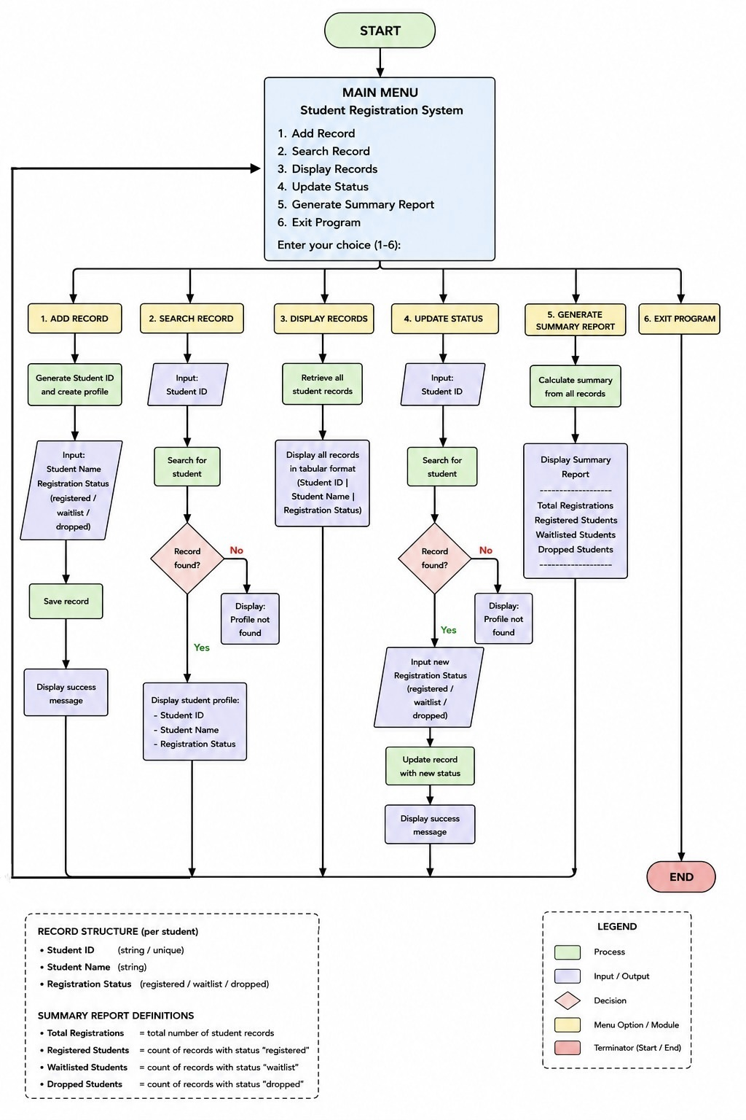
Team Responsibilities
Team member | Role | Responsibilities
Lewis Russ | Documentation manager | Assist with planning, review project requirements, and assist with documentation management.
Samuel M. Brousett | Project Designer | Designs the flowchart and assists with planning.
Dwyhan Angulo | Software Developer/GitHub coordinator | Develops the Student Registration System/Tests the software/Designs GitHub.
Tommy Martinez | Quality Assurance Coordinator | Monitors project progress, coordinates team activities, and ensures requirements are met.

GitHub Setup
Figure 2
Repository Home/Contriubtors
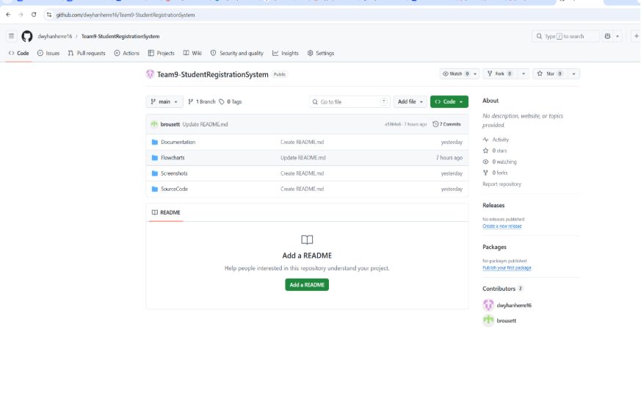

Figure 3
Readme File
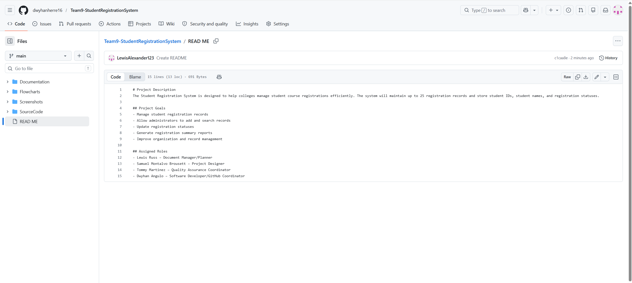

Figure 4
Commit History
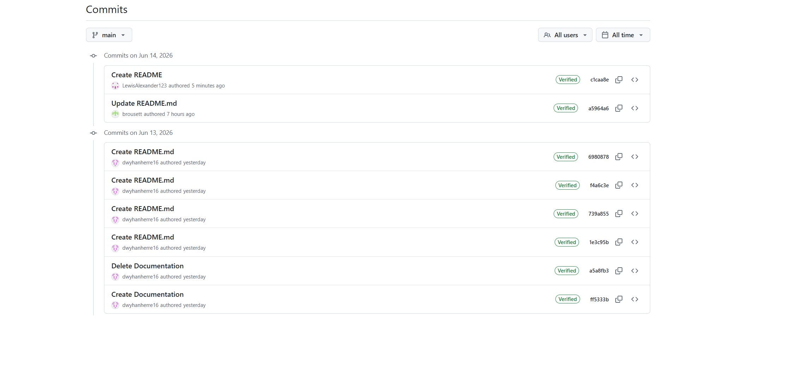

References
GitHub. (2025). GitHub documentation. https://docs.github.com
Purdue Online Writing Lab. (2025). APA formatting and style guide. https://owl.purdue.edu
Python Software Foundation. (2025). Python documentation. https://docs.python.org

